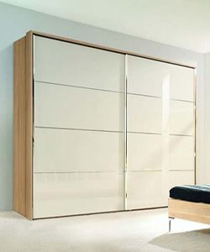

Sliding Wardrobe with Gloss Magic

$294.11

Availability: In stock

Description

We offer Sliding Wardrobe with Gloss Magic to our valuable customers. Made as per the industry laid standards, these wardrobes are known for its appealing look and spacious interiors. Appearance-Modern Type-Triple Door-No. Of Shelves 5 Shelves Surface-Finish Plywood, MDF, Particles-Material Solid wood, MDF, Mirror Door Material Solid Wood, Maple solid wood Available with us at highly affordable market prices, these wardrobes are available in customers stated specifications. To ensure a defect free range, these wardrobes undergo different predefined quality assurance tests by our team of quality controllers.